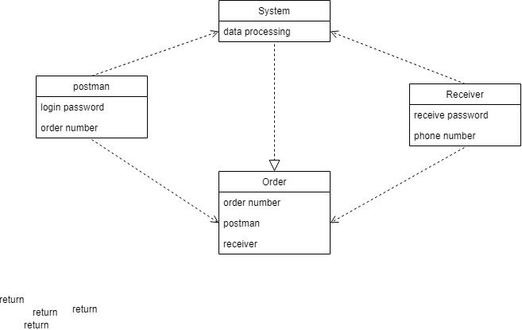

Association definitions

The order can be queried by the senders and the receivers, so the relationship between them is that the order depends on the senders and the receivers.

Attribute definitions

Order order number, postman, receiver

Postman login password, order number

Receiver receive password, phone number

System data processing